RESUME

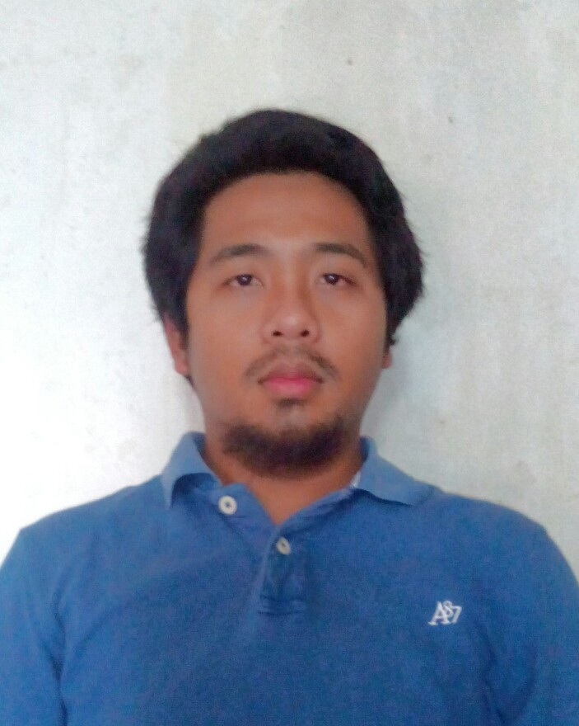
PERSONAL DETAILS

Name : Sony Andriana
NRIC Number : 871016-43-5177
Gender : Male.
Age : 29 years-old.
Date / Place of Birth : 16-october-1987.
Race : Malay.
Religion : Islam.
Marital Status : Married
Height / Weight : 170 cm / 73 kg.
Nationality : Malaysian.

Spoken / written languages : Malay and English (average).
Drive license : Class B2,D

Permanent Address : Lot 619 Jalan Kundang Padang Jawa,

ADDRESS AND CONTACT NUMBER

41300 Klang,
Selangor Darul Ehsan.
Tel. No. : 017-6605501
Email address :sony_andriana@yahoo.com

EDUCATIONAL BACKGROUND
a) November 2009 – may 2010 Diploma Eksekutif Rangkaian Komputer Dan Aplikasi
(Universiti Tun Hussein Onn Malaysia(UTHM)
Industrial Skills Enhancement Programme (INSEP)
b) September 2005 - January 2008 Diploma In Multimedia Technology
c) January 2000 - November 2004 Sekolah Menengah Seksyen 16 Shah Alam
WORKING EXPERIENCE
UCE SDN BHD
Huawei Front Office Surveillance Engineer
Gabs Project ( maxis sdn bhd )
- Real- time management of Huawei 2G,3G & 4G Base station Product via U2000
- Perform 1st/ 2ndlevel troubleshoot upon any alarm received via U2000
- Create ticket Via Across ticketing system and escalate to Field Support
- Guide field support remotely to perform troubleshooting at site and solve issue.
- Handle & troubleshoot problems related to power failure, equipment failure &
also human error mistakes. Pre- troubleshoot problems before they cause major
outages such prevention of a site to go down which would affect call processing
- Prepare daily performance report for customer.
- Troubleshoot performance abnormalities for customer complaints.
- Maintain and meet customer SLA & KPI’s.
- Hands on training with Huawei 2G,3G and 4G equipment, provided by customer.
LTE P1 Project ( P1 wimax )
- Real- time management of Huawei 4G Base station Product via U2000
- Perform 1st/ 2ndlevel troubleshoot upon any alarm received via U2000
- Create ticket Via Across ticketing system and escalate to Field Support
- Helping TM Noc to resolve Backbone issue
Binasat Sdn Bhd
Field Engineer – Gabs Project ( Sept 2014 – May 2015)
- Perform Corrective Field Maintenance: carried out to fix or adjust significant equipment defects and failure, including the on-site diagnosis and required replacement of units, boards, parts, modules, circuit cards and components.
- Perform Routine & Preventive Maintenance: periodical program of activities performed on site includes of checks, adjustments, tests, measurement, internal and external cleaning, surveys and analysis.
- Main contractor for Maxis for the work of equipment maintenance
- Testing and commissioning of replaced equipment
- Maintenance, repair activities inclusive of preventive and corrective maintenance
- Installation and testing of telecommunication equipment and related infrastructure
- Prepare Fault Reports
- Involve with software configuration for LMT,U2000 & BTSM.
- Prepare daily report for customer.

B-Band Communication Sdn Bhd
Project Excutive ( Jan 2011 – Oct 2014 )
- Survey site for install equipment and prepair for document survay
- Survey & design Maxis NGBB OLT project including preparation of technical proposal, installation, testing, commissioning, configuration & integration.
- Survey & design Maxis Mobile Backhaul including installation, test, commisioning, integration and migration to Node B
- Installation of Core Network equipment for U Mobile, Maxis, Celcom, Digi and P1.
- Rectification works for Maxis 3G swap sites
- Design, install, test and commissioning of Maxis NGBB Project for both home pass and home connection.
- Application for wayleave and permit to carryout NGBB Project.
Technical Engineer (under HUAWEI)
- Perform Corrective Field Maintenance: carried out to fix or adjust significant equipment defects and failure, including the on-site diagnosis and required replacement of units, boards, parts, modules, circuit cards and components.
- Troubleshoot physical equipment
- Troubleshoot 2G and 3G equipment (HUAWEI BBU3900) for GABs project
- Troubleshoot CX600,OLT5600T and MA5612 for NGBB project
BCS Engineer
- Coordinate sub-con at site to swap 2G/3G & 4G Motorola to Huawei
- Load scrip site from softwere LMT,web LMT and M2000
- Run test 2G,3G and LTE new site
- Prepair the document test .

REFERENCES

Muhammad Syafiq Mr Reedzuan

Front Officer Project Manager Bband Communication
012-9746490 No.7, Jalan Nilam 1/5,
No. 7-9, Jalan Nilam 1/5, Subang Hi-Tech Industrial Park,
Subang Hi-Tech Industrial Park, Batu Tiga, 40000 Shah Alam,
Selangor Darul Ehsan, Selangor Darul Ehsan.
40000 Shah Alam,

Malaysia

.

